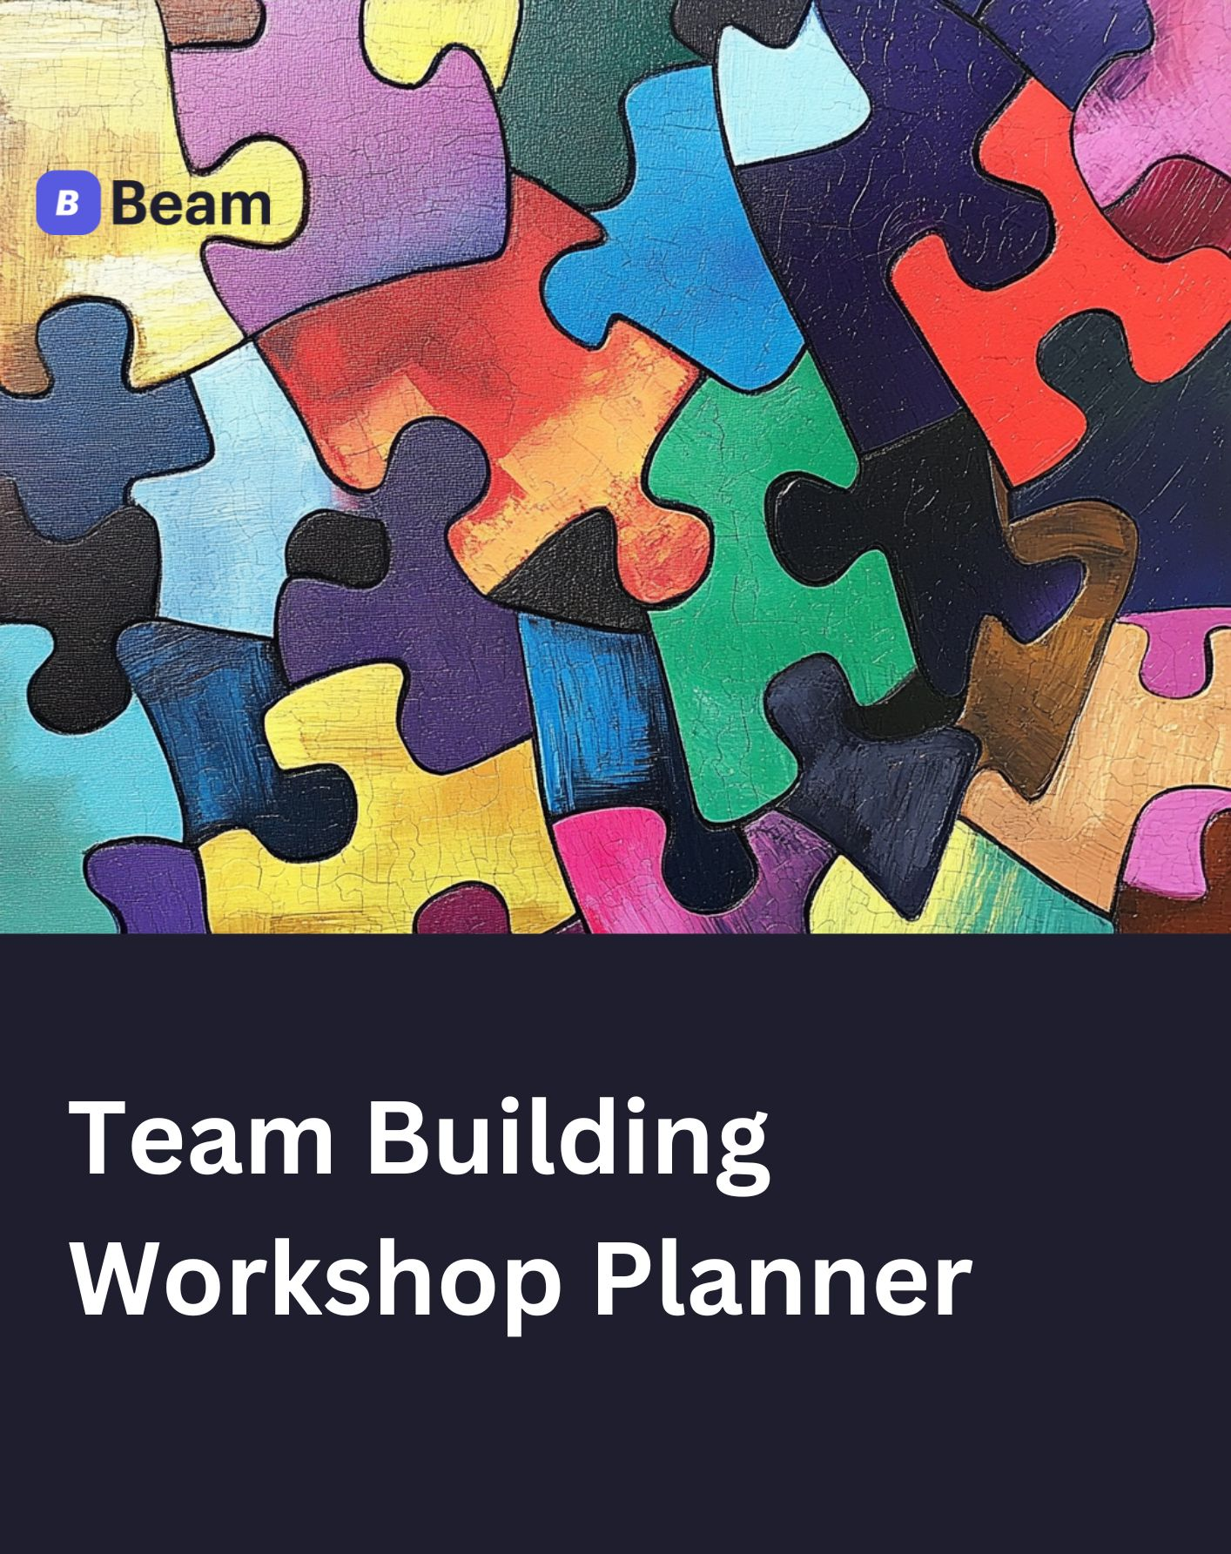

To use this document, edit this version to fit your needs, or go to “File” and then “Download As” and select “Microsoft Word” to download.

How to Use this Team Building Workshop Planner
Define Objectives and Understand the Audience
Clarify your workshop goals, focusing on outcomes like improved communication or collaboration. Identify participants' interests and challenges to tailor activities for maximum relevance.
Select Activities
From the Activity Guides, choose a variety of exercises that align with your objectives, ensuring diverse engagement.

Create an Agenda
Using our planner, draft a workshop agenda that outlines the flow of the session, outlining start and end times, breaks, and activity durations to keep the session on track.
Prepare Materials
Gather necessary supplies and arrange logistics, including venue setup and equipment. And you’re ready to facilitate.

Evaluate Success
Collect feedback to assess effectiveness and identify areas for improvement in future workshops.

Facilitator Tips: Best Practices for Successful Workshops

1. Prepare Thoroughly  Know Your Material: Familiarize yourself with all activities and their objectives. Practice explaining instructions clearly and concisely.  Anticipate Questions: Prepare answers for participants' questions about each activity.  Have a Backup Plan: Prepare alternative activities or modifications in case of unexpected challenges or time constraints. | 2. Create a Positive Atmosphere  Set the Tone: Begin the workshop with enthusiasm and a welcoming demeanour to encourage participation.  Use Icebreakers: Start with a quick, engaging activity to help participants relax and connect.  Encourage Inclusivity: Ensure all participants feel valued and heard throughout the session.
3. Facilitate Discussions Skillfully  Ask Open-Ended Questions: Encourage deeper reflection and dialogue among participants.  Use Visual Aids: Employ slides, handouts, or whiteboards to reinforce verbal instructions.  Communicate Timeframes: Clearly state how long each activity will take and give time warnings (e.g., "5 minutes left"). | 4. Gather and Utilise Feedback  Conduct Mid-Workshop Check-ins: Ask for a brief  feedback during breaks to make real-time  adjustments if needed.  End with a Feedback Session: Allow time for  participants to share their overall workshop  experience.  Use Feedback for Improvement: Apply insights gained  to enhance future workshops.

Activity Guides
These guides will provide detailed instructions for facilitators to implement practical team-building exercises.

Activity Guide 1

Icebreaker: Two Truths and a Lie
Objective: To help team members get to know each other in a fun, engaging way.
Duration: 15-20 minutes
Instructions:
- Have each participant write three statements about themselves - two truths and one lie.
- Go around the room, allowing each person to share their statements.
- After each person shares, the group votes on which statement they think is a lie.
- The person reveals the lie and may elaborate on the truth.

Tips:
- Encourage creative, unexpected truths to make the game more challenging.
- Use this activity at the beginning of the workshop to create a relaxed atmosphere.

Activity Guide 2

Problem-Solving: The Marshmallow Challenge
Objective: To promote teamwork, creativity, and innovative thinking.
Duration: 30-45 minutes
Materials needed:
- 20 sticks of spaghetti
- 1 yard of tape
- 1 yard of string
- 1 marshmallow per team
Instructions:
- Divide participants into teams of 4-5 people.
- Provide each team with the materials.
- Challenge teams to build the tallest free-standing structure possible in 18 minutes.
- The marshmallow must be placed on top of the structure.
- After the time is up, measure each structure. The tallest one wins.
Debrief questions:
- What strategies did your team use?
- How did you collaborate and divide tasks?
- What would you do differently next time?

Activity Guide 3

Communication Exercise: Back-to-Back Drawing
Objective: To improve communication skills and highlight the importance of clear instructions.
Duration: 20-30 minutes
Materials needed:
- Paper and pens for each pair
- Pre-drawn simple images

Instructions:
- Divide the group into pairs, sitting back-to-back.
- Give one person in each pair a pre-drawn image.
- The person with the image must describe it to their partner without using shape names (e.g., "square," "circle").
- The partner tries to draw the image based solely on the verbal description.
- After 10 minutes, pairs compare the original and the drawn image.

Debrief questions:
- What challenges did you face in communicating/interpreting the instructions?
- How could the describer have improved their communication?
- How does this relate to workplace communication?

Activity Guide 4

Trust-Building: Blind Obstacle Course
Objective: To build trust and improve communication between team members.
Duration: 30-40 minutes
Materials needed:
- Blindfolds
- Various objects to create obstacles (chairs, boxes, etc.)
Instructions:
- Set up an obstacle course in an ample open space.
- Divide participants into pairs.
- One person is blindfolded while the other guides them through the course using only verbal instructions.
- Switch roles and repeat with a new course layout.
Safety note: Ensure the area is clear of hazards and have additional facilitators monitor the activity.

Debrief questions:
- How did it feel to rely entirely on your partner's guidance?
- What made the communication effective or ineffective?
- How can we apply these trust-building principles in our daily work?

Activity Guide 5

Collaboration Activity: Silent Line-Up
Objective: To encourage non-verbal communication and teamwork.
Duration: 15-20 minutes
Instructions:
- Ask all participants to line up in a straight line.
- Inform the group they must arrange themselves in a specific order (e.g., by birth month, height) without speaking.
- Allow them to develop their system of non-verbal communication.
- Once they believe they're in the correct order, have them say their criterion (e.g., birth month) out loud to check accuracy.
Debrief questions:
- What strategies did you use to communicate without words?
- How did the team coordinate their efforts?
- What does this activity reveal about our team's ability to collaborate under constraints?

Workshop planner template

Overview
Provide background information and let participants know what to prepare before your workshop.
Workshop date
Title
Objective
Facilitator
Participants
Resources
Workspace
Pre-workshop tasks

Agenda
Present the workshop itinerary and explain how participants should follow the schedule and participate.
Time | Exercise | Instructions
e.g. 2-3 pm | e.g. icebreaker activity | e.g. participants should complete and present

Outcomes
Record decisions, track open questions, and plan steps once the workshop is completed.
Issues | Status | Owner | Next steps
e.g Gathering feedback from workshop participants. | Decision/ Update/Blocker/Ambiguity/Other

Workshop Agenda Template

Communication Skills Workshop
Duration: 3hrs
Objective: Improve team communication and collaboration

Time | Exercise | Instructions
9:00 AM | Welcome and Introduction (15 min)
9:15 AM | Icebreaker: Two Truths and a Lie (20 min)
9:35 AM | Mini-lecture: Effective Communication Principles (25 min)
10:00 AM | Activity: Active Listening Exercise (30 min)
10:30 AM | Break (15 min)
10:45 AM | Role-playing: Difficult Conversations (45 min)
11:30 AM | Group Discussion: Applying Learnings to Workplace (20 min)
11:50 AM | Wrap-up and Action Planning (10 min)

Problem Solving Workshop
Duration: 4hrs
Objective: Enhance team problem-solving skills and creative thinking.

Time | Exercise | Instructions
1:00 PM | Welcome and Objectives Overview (10 min)
2:10 PM | Icebreaker: Marshmallow Challenge (30 min)
1:40 PM | Mini-lecture: Problem-Solving Frameworks (20 min)
2:00 PM | Group Activity: Case Study Analysis (45 min)
2:45 PM | Break (15 min)
3:00 PM | Brainstorming Session: Workplace Challenges (40 min)
3:40 PM | Team Presentations (30 Min)
4:10 PM | Reflection and Action Planning (20 min)
4:30 PM | Closing Remarks (10 min)

Trust-Building Workshop
Duration: Half-day (5 hours)
Objective: Foster trust and strengthen team relationships

Time | Exercise | Instructions
1:00 PM | Welcome and Creativity Warm-up (30 min)
2:10 PM | Mini-lecture: Principles of Innovation (25 min)
1:40 PM | Activity: Reverse Brainstorming (40 min)
2:00 PM | Break (15 min)
2:45 PM | Design Thinking Exercise: Empathy Mapping (60 min)
3:00 PM | Lunch Break (60 min)
3:40 PM | Ideation Techniques Workshop (45 min)
4:10 PM | Reflection and Action Planning (20 min)
4:30 PM | Closing Remarks (10 min)

Innovation and Creativity Workshop
Duration: Full-day (7 hours)
Objective: Stimulate innovative thinking and creative problem-solving

Time | Exercise | Instructions
9:00 AM | Welcome and Creativity Warm-up (30 min)
9:30 AM | Mini-lecture: Principles of Innovation (25 min)
9:55 AM | Activity: Reverse Brainstorming (40 min)
10:35 AM | Break (15 min)
10:50 AM | Design Thinking Exercise: Empathy Mapping (60 min)
11:50 AM | Lunch Break (60 min)
12:50 AM | Ideation Techniques Workshop (45 min)
1:35 PM | Group Project: Innovative Solutions (90 min)
3:05 PM | Break (15 min)
3:20 PM | Project Presentations (45 min)
4:05 PM | Reflection and Implementation Planning (25 min)
4:30 PM | Closing Remarks and Next Steps (15 min)

Evaluation
Evaluation forms are designed to collect feedback from participants about their experiences during the workshop. This feedback helps facilitators understand what worked well, identify areas for improvement, and measure the overall impact of the workshop on participants.

Sample Workshop Evaluation Form
Thank you for participating in our team-building workshop. Your feedback is invaluable in helping us improve future sessions.

Participant’s Information
Name
Department

1. Workshop Content and Delivery

Relevance of content
Rate the relevance of the workshop content to your role? (1-5 scale)

Objectives met
How effectively were the workshop objectives met? (1-5 scale)

Most valuable Part
What part of the workshop did you find most valuable? (open-ended)

2. Facilitation Quality

Engagement by facilitator: (Include Facilitator's Name)
Rate the facilitator’s ability to engage participants (1-5 scale).

Clarity of instructions
Rate the facilitator’s ability to engage participants (1-5 scale).

Suggestions for facilitation
Provide suggestions for improving facilitation (open-ended).

3. Activities and Engagement

Engagement level
Rate your level of engagement during activities (1-5 scale).

Favourite activity and reason
Which activity did you enjoy the most and why? (open-ended)

Less effective activities
Were there any activities you found less effective? Please explain. (open-ended)

4. Logistics and Organization
Organisation rating
Rate the organisation of the workshop (1-5 scale).

Venue suitability
How suitable was the venue for this workshop? (1-5 scale)

Logistical improvements
What logistical improvements do you suggest? (open-ended)

5. Overall Experience
Overall satisfaction
Overall satisfaction with the workshop (1-5 scale).

Recommend to others
Would you recommend this workshop to others? (Yes/No)

Additional comments
Additional comments or suggestions for future workshops (open-ended).

Tips for Using Evaluation Forms

Anonymity: Consider allowing anonymous submissions to encourage candid feedback.
Digital Options: Use digital tools like Google Forms or SurveyMonkey for easy distribution and analysis.
Follow-Up: Share a summary of feedback with participants and outline any planned improvements based on their input.

